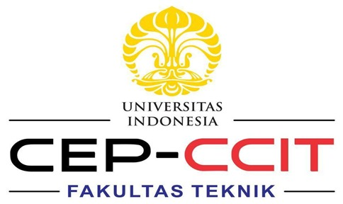

**Concert ticket sales application**

Names : 1. Hilmy Yafiansyah

2. Mutia Rahma Alifah

3. Salwa Widyna Khairani

Faculty : Mr. Aryajaya Alamsyah, S.Kom., M.Kom., MTA.

Class : 2WD1

**CEP CCIT**

**FAKULTAS TEKNIK UNIVERSITAS INDONESIA**

**2023**

# PREFACE

First of all, Thanks to Allah SWT for helping and giving us a lot of motivation to complete this project, peace, and salutation may also be upon the most honorable prophet Muhammad SAW, who had taught us that there is nothing more precious than seeking knowledge.

**Concert ticket sales application**

Batch Code : 2WD1

Start Date : April 22, 2024

End Date : May 12, 2024

Name of Faculty : Mr. Aryajaya Alamsyah, S.Kom., M.Kom., MTA.

Names of Developer :

1. Hilmy Yafiansyah

2. Mutia Rahma Alifah

3. Salwa Widyna Khairani

Date of Submission : May 12, 2024



# PROJECT ON

**Ticket concert application**

**Developed by**

1. Hilmy Yafiansyah

2. Mutia Rahma Alifah

3. Salwa Widyna Khairani

# CERTIFICATE

This is to certify that this report, titled “Concert ticket sales application”, embodies the original work done by Hilmy Yafiansyah, Mutia Rahma Alifah, and Salwa Widyna Khairani, in partial fulfilment of their course requirement at NIIT.

Coordinator:

Mr. Aryajaya Alamsyah, S.Kom., M.Kom., MTA.

# ACKNOWLEDGEMENT

The authors want to praise Allah, the Most Merciful, and that the authors can complete Project 1 entitled “Concert ticket sales application”. We would like to thank our faculty Mr. Aryajaya Alamsyah, S.Kom., M.Kom., MTA., who has given us useful advice that helped us in writing this article.

The authors recognizes that this paper is far from perfect, therefore, all criticisms and suggestions from readers will be welcomed by the authors in order to improve the manuscript of this research further. The authors express his gratitude to all those involved in writing this script.

# BACKGROUND

In an era where live entertainment is increasingly popular, concert ticket sales have become increasingly important. However, the ticket sales process is often inefficient, leading to long lines, limited accessibility, and the risk of fraud.

To overcome these challenges, the development of a concert ticket sales app is the expected solution. Through a sophisticated digital platform, the app will make it easier for users to purchase tickets online, increase accessibility, and reduce the risk of fraud. With the latest technology, the app aims to revolutionize the concert ticketing experience, providing benefits to users, promoters, and artists.

# SYSTEM ANALYSIS

System analysis of this project using the Java programming system. The goal of this project is to create a system on the web in the form of purchasing concert tickets, which aims to make it easier for visitors who want to buy concert tickets but do not have to buy on the spot.

# Design Interface & System Application

1. Program Files

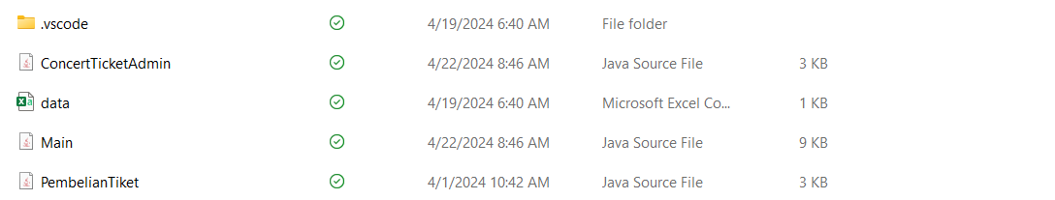

Figure 1 (Ticket Conser files)

1. **Authentication and Library**

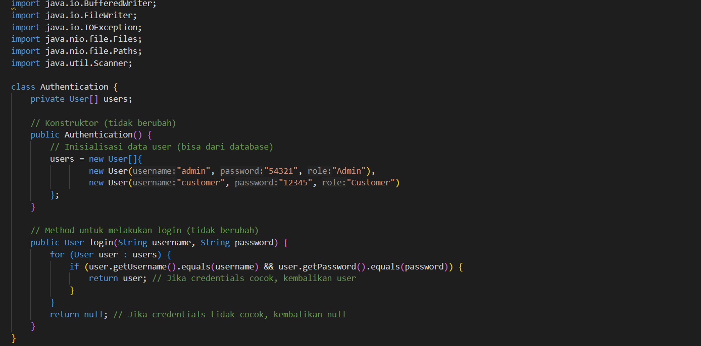

Figure 2 (Authentication and Library)

1. **Class user**

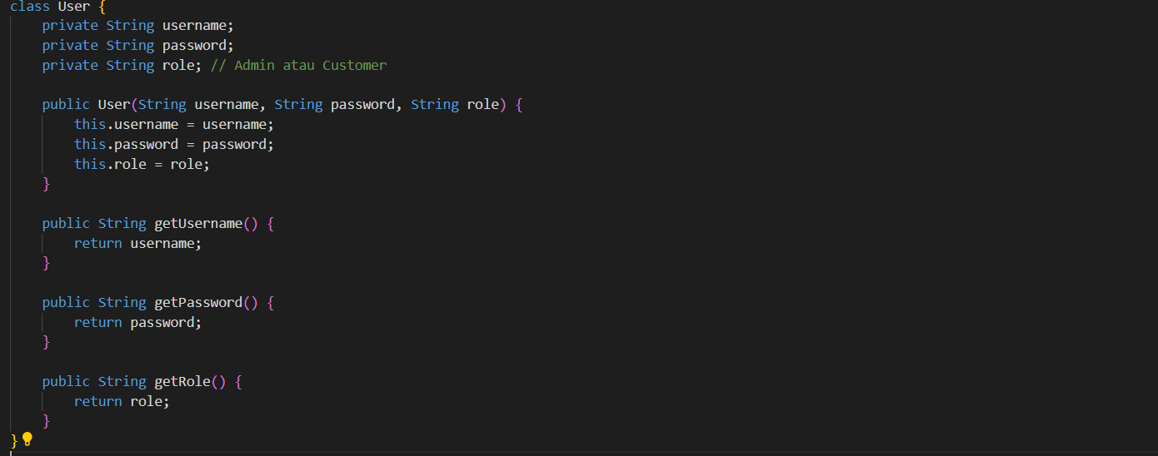

Figure 3 (Class user)

1. **Admin menu**

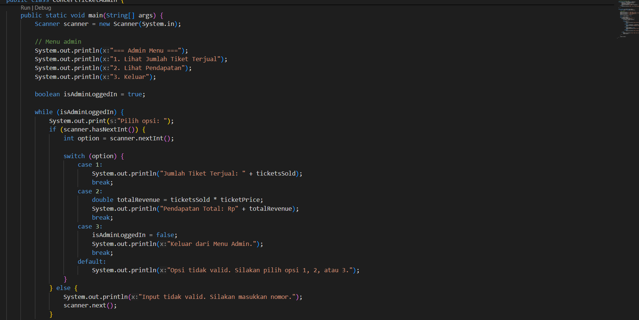

Figure 4 (Admin Menu)

**5. Main menu**

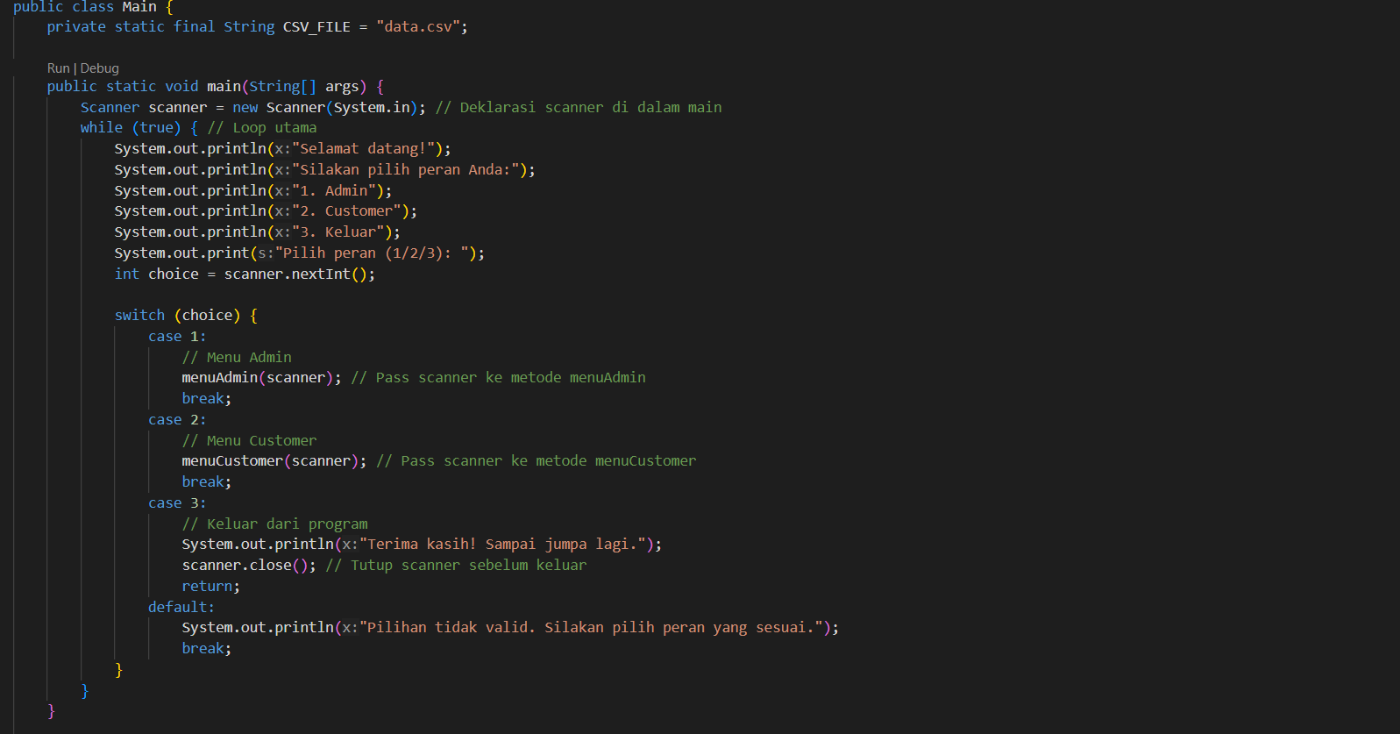

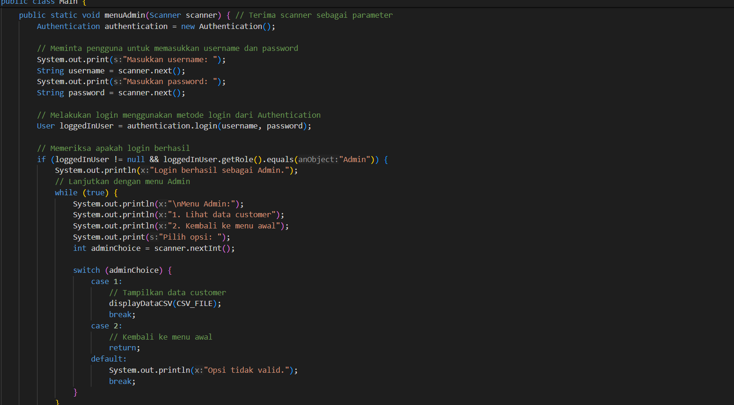

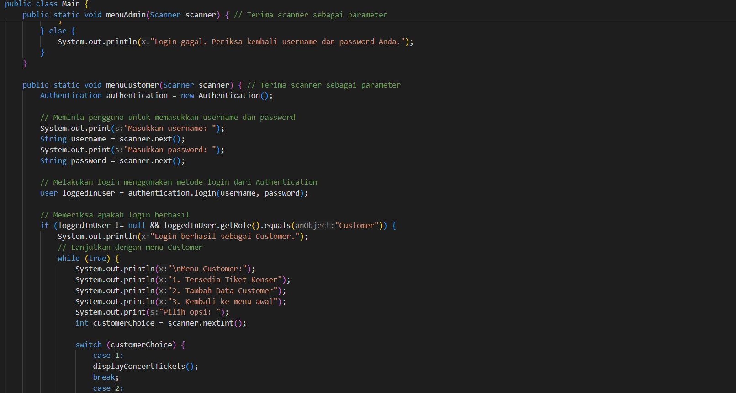

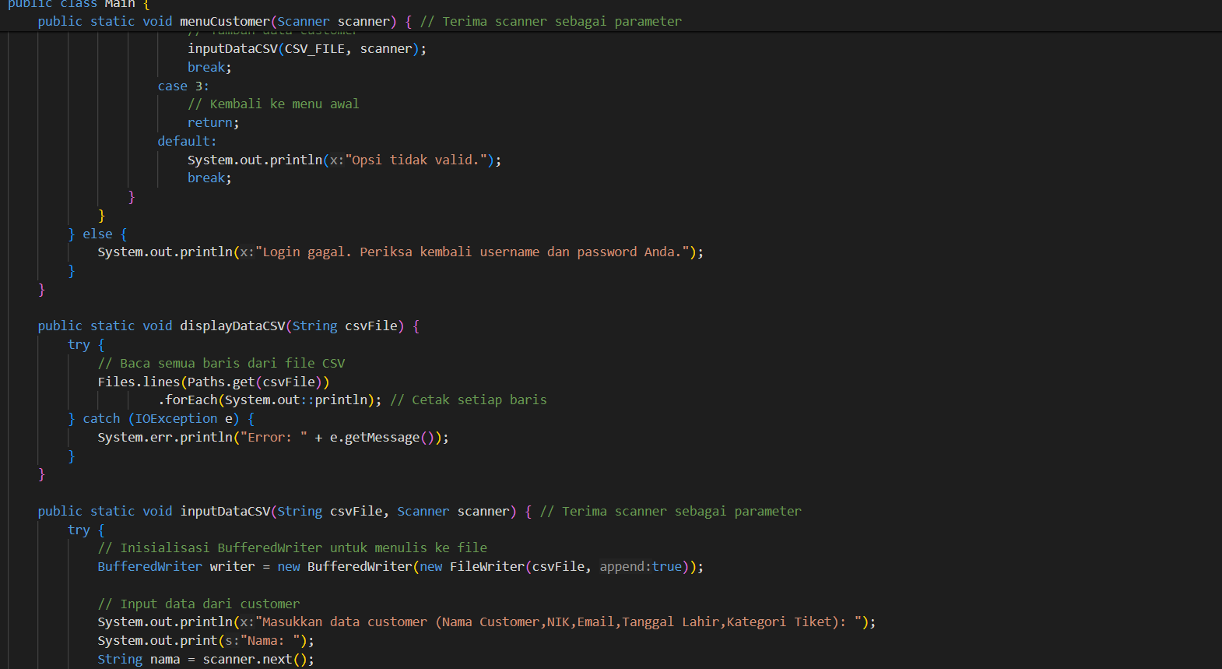

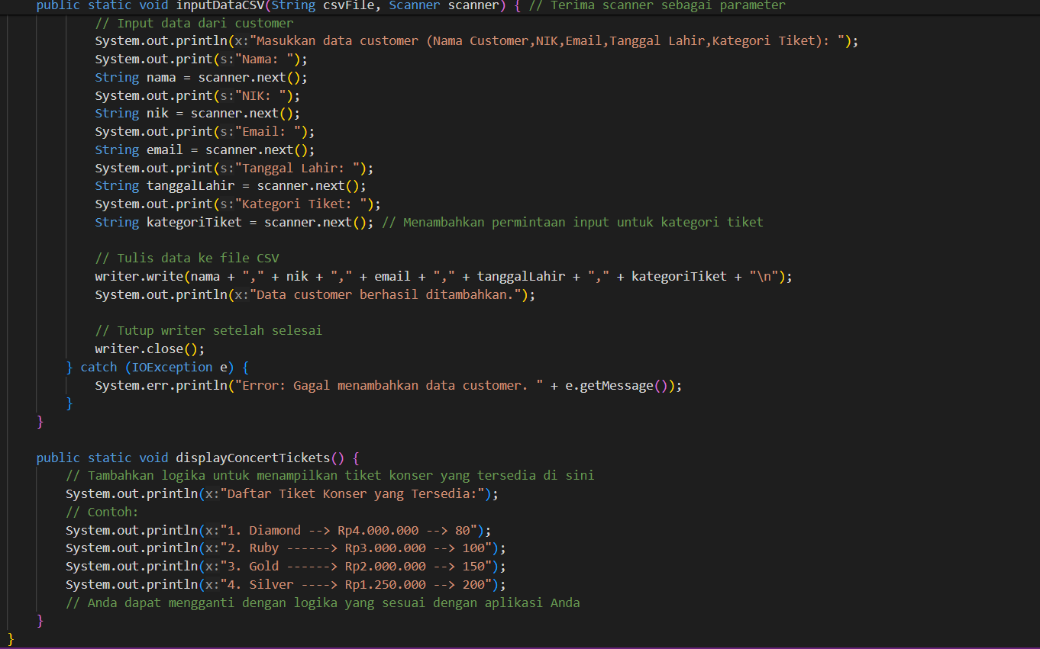

Figure 5 (Main menu)

**6. Ticket buying**

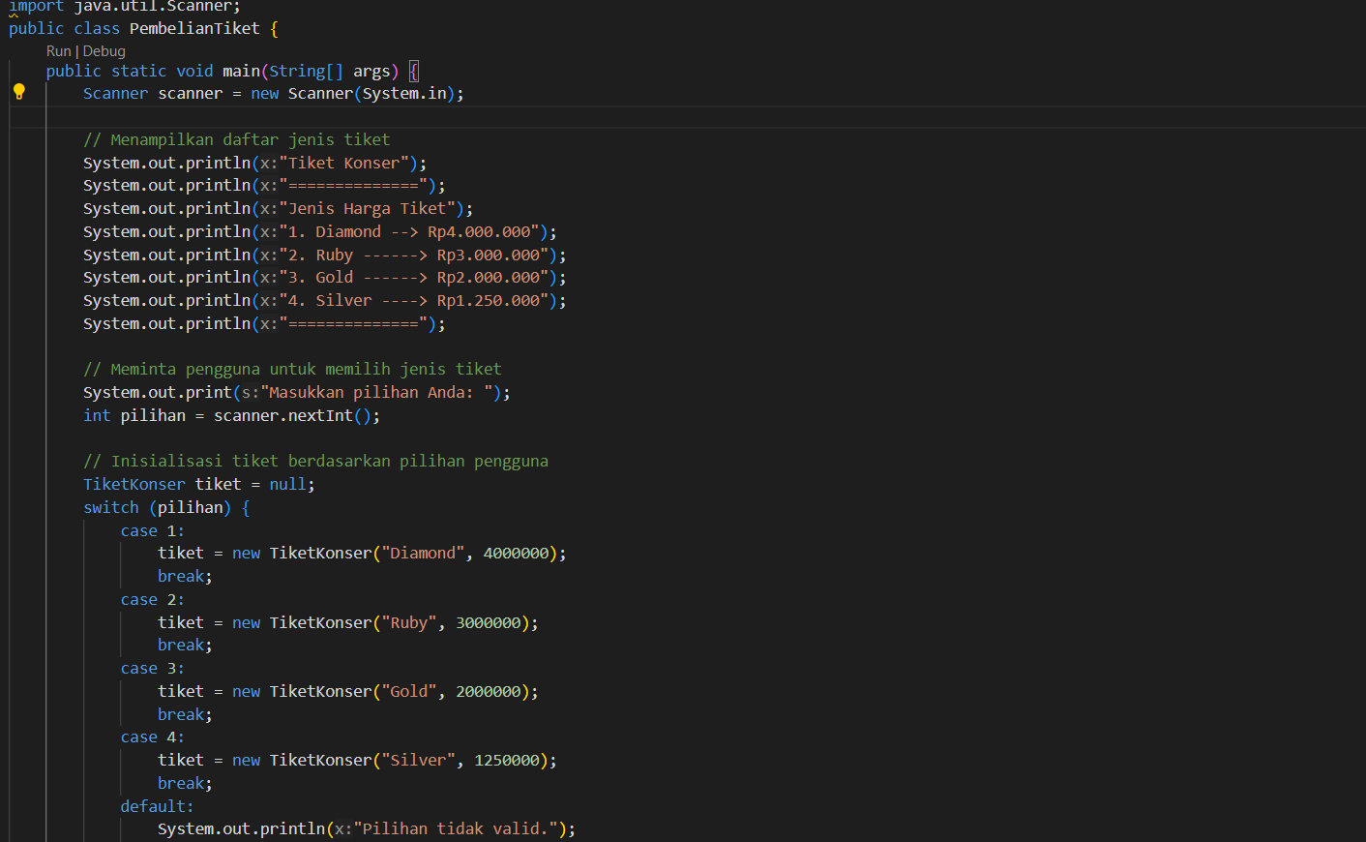

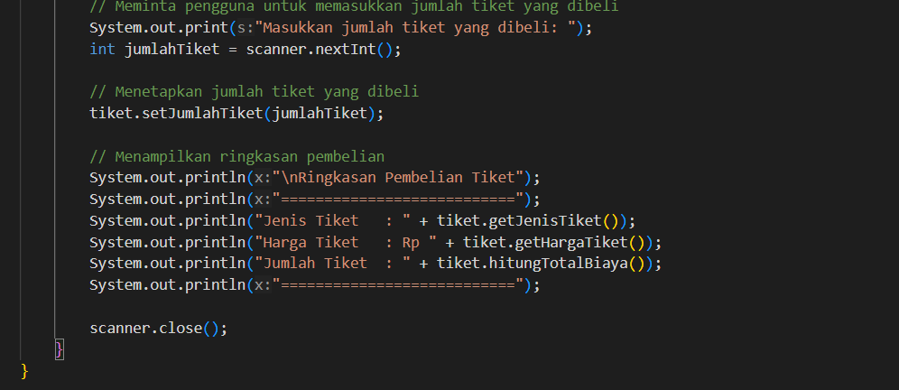

Figure 6 (Buy the ticket)